KOP
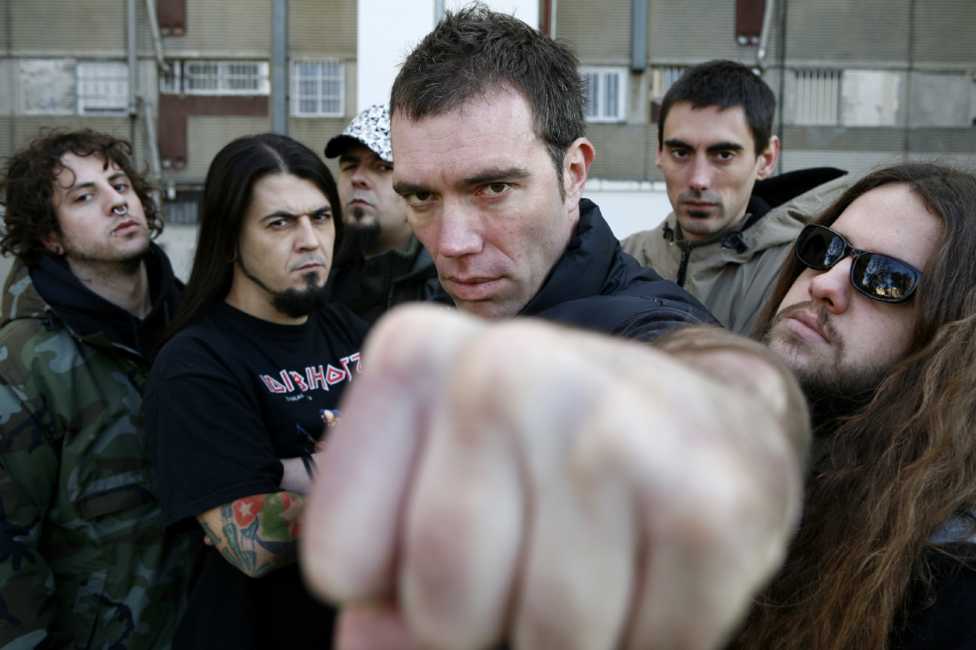

Sol el poble salva al poble!

Band Details

Hometown: Barcelona
Year: 1.992

Style: hardcore, metal
Musicians: six musicians

Biography
KOP is a hardcore-metal that was formed after 10 years of rocking the Spanish state underground hardcore scene under the name of Speereth. From the late eighties until KOP was born, the band released 2 albums and toured intensively the Spanish state with Speereth project. Once KOP was foundated, they soon recorded their first album “Internacionalista” (1998). The album broke the standards of metal music in Catalonia: musical production and the high capacity of the band to face new levels, stablished KOP as the most contundent hardcore-metal band of the Spanish State in those years.

In 1999 the excelent public feedback to the band and its strong live show guided them to tour again the whole Spanish state, including Catalonia, Aragón, Euskadi, Madrid, Galiza and Andalucia. Same year they started its first European tour.

On his second recording “Ofensiva” (2001) KOP incorporated electronic music as a differencial element, offering a contundent and advanced sound. They reached playing with Soulfly opening for Cavalera’s band 2001 Spanish Tour and affronted their third European tour, visiting more than 30 cities all over France, Holland and Germany. They closed that season in Barcelona, where they played for 15.000 people.

At the end of 2001 the band was forced to stop playing. This period was broken in 2007 with the edition of their last record “Nostrat” that includes 5 new songs and 6 covers of their own songs made by other Catalan and European bands (Berri Txarrak, Banda Bassotti, Boikot, Obrint Pas…)

After a long wait the band is here again. After their first concert on 9th of January 2009 where they sold out all tixkets in 10 days and three weeks ago before the show, they are walking straght to all stges of Spain and Europe. Big chance to enjoy with their astonishing and kick-ass and lyrics.

Discography referentes (no compilations included)
KOP: Nostrat - Edited for: Propaganda pel fet! (2007)
KOP: Ez etsi, No et rendeixis, No te rindas– Edited for: Propaganda pel fet! (2001)
KOP: Ofensiva – Edited for: Propaganda pel fet! (2001)
KOP: Internacionalista – Edited for: Propaganda pel fet! (1999)

Contact and Booking
For further information feel free to put on contact with us at the following e-mail adress and telephone:

Litus, Carles Tenesa
litus@propaganda-pel-fet.cat / 93 878 74 71 – 615276902

www.kop.cat www.myspace.com/kopantifa www.propaganda-pel-fet.cat

